More Than
Two Boats
And an
Island

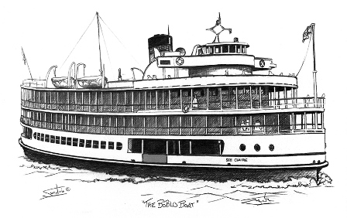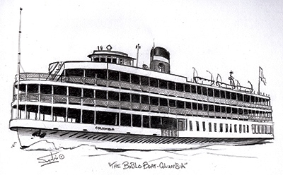

Tom O’Neal
Forward
Throughout a person’s life events happen that are more important than others; this is a story about an event or several events that occurred in the life of Tom O’Neal from Andalusia, Alabama.
It is important to know in order to help his dad pay for his college education, beginning in high school, Tom always worked in the summer doing jobs like working with the REA keeping the roadsides cut, Andalusia Coca Cola Bottling Company, bottling cokes, his uncle Henry Lee Mullin’s Chicken Farm, washing cars, pumping gas, etc. at the Hill Top Service Station and others.
This story begins in the year of 1961-1962 when Tom was attending the University of Southern Mississippi in Hattiesburg, Mississippi. Tom discussed with his dad the possibility of working on an iron ore boat on the Great Lakes. His dad told him he would talk to one of his friends who had retired from the Merchant Marines to see if he might know what needed to be done to join the Merchant Marines and get on an iron ore boat.
At that time the Merchant Marines was under the auspices of the United States Coast Guard; in order to get a job with the Merchant Marines he/she had to be approved by the Coast Guard. Tom went to Mobile, Alabama, filled out the appropriate forms, was finger printed and was told he would hear something within a month.
Tom went back to college and in a month he received his ‘Seaman’s Papers’ approving him to work as an “Ordinary Seaman, Wiper or in the Steward’s Department.” He also had learned that in order to work on most ships in the United States a person had to join the Seafarers International Union.
When the Semester ended, he went home, packed a duffel bag, went to Montgomery, Alabama and bought a Train Ticket for Detroit, Michigan. It left Montgomery about 9:00 pm and arrived in Detroit in mid-morning. And this begins the event(s) that would leave an everlasting memory of two summers and also helped mold Tom O’Neal into an adult…
This book was written in honor of and dedicated to the people of “Bob-Lo.” Although there are some facts and statistics at the end of the book, it is not intended for this to be a book of Bob-Lo History. It simply represents the love for those two summers and the appreciation of everyone who made it possible for Tom to experience these two years of his life.
One more thing….please forgive him if there’s a wrong name or a name he can't think of it…but it seems that Tom can’t remember lots of things. His memory is so bad he’s been nominated for the President of the CRS Club.
It's been 53 years since Tom helped get the Ste Claire ready for the winter on the day after Labor Day in 1962. He has not been to Detroit since then. This July 31st, 2015 (week after next) there’s going to be another Bob-Lo reunion and he’s going. To say that he’s excited about attending his first reunion would be a gross understatement.
Tom would like to thank Karen Winkler and Jill Lezotte-Kates for helping him coordinate his trip and for being his guide and taxi.

INDEX
Forward and acknowledgments
Chapter 1 Shaky Start Page 1
Chapter 2 “Bob-Lo” (The Short Version) Page 3
Chapter 3 “The Boats” Page 4
Chapter 4 “Bob-Lo” (The Long Version) Page 5
Chapter 5 More Than… Page 6
Chapter 6 Excerpts from the People Page 10
Who worked at Bob-Lo
Chapter 7 Interesting Facts Regarding “Bob-Lo” Page 11
Pictures Page 13

Chapter One: Scary Start

Needless to say, I didn’t sleep much on the train ride to Detroit, Michigan. To be perfectly honest, I was Scared!
The first thing I did when I arrived in Detroit was go to a pay phone and look up the number of the Seafarer’s International Union Hall. I also wrote down the number of the address. – 10227 W. Jefferson – River Rouge 18, Michigan. After securing this information, I went outside and hailed a cab.
When we reached the Union Hall I went in and asked to see the President. I had to wait for about 45 minutes, but when I was finally permitted to see him my introduction was: “My name is Tom O’Neal, I’m from Andalusia, Al and I would like to join the union. I will do anything to show you I’m a good worker.” He asked me how old I was and how I had gotten all the way to Detroit (River Rouge); I told him and he said, well I’ve never had anyone to come as far as you’ve come to get a job; we need a custodian for the Union Hall; would you be willing to do that so we can observe you work; and of course I said YES! He asked me how much money I had and I said, “Not Much!” He then wrote a note and gave it to me along with a book of stubs. He said, when you go out of the Union Hall go left for one block, and then turn left and go another block. At the end of the block will be a lounge and there rooms on top of the lounge; give them this note and they will give you a room. He then gave me the stubs and said, “this will get you two meals a day and then gave me the location of the cafe. Our conversation ended with… “If you want you can start today, this place is a mess.” I asked where the cleaning supplies were and he told me in the basement. I took my duffel bag down to the basement and started to work.
When the Union Hall closed, I took my duffel bag and walked to the Lounge and gave the note to the bartender and he showed me the stairway saying, “pick any room, no one is up there. I went up and immediately fell asleep. About 10:00 I woke up and from then to about 2 in the morning, there was too much noise coming from below to sleep. The next morning I took my bag and went to the café, had breakfast and started my second day as the union hall custodian. From that evening on, I slept in the union hall. It had shower facilities; plus it allowed me to work extra hours.
If you’ve never gotten a job through the Seafarers International Union, I should explain a couple of things. When you first go to the union hall, they give you a card with a number on it. Union Members get blue cards and non-union members get white cards. The number represents the order in which you arrived; in other words, if there were 10 union members waiting to get a job and you walked in and asked for a card, you would get card #11.
When a job became available they would post the job on a board. Every hour on the hour, if a job was available and on the board, they would ‘call the job’ and if you were interested in it, you would go to the ‘job window’ and put your card in. The lowest number got the job and any blue card, no matter what the number was, would bump a white card…. I suspected I was going to be their custodian for a long-long time.

1
After about 10 days one of the union hall bosses found me and told me to go and get my duffel bag and meet him behind the union hall. I got my bag and met him behind the hall and there was a taxi. He told the driver to take me to the Bob-Lo Office at the foot of Woodward Ave. and the Detroit River; he gave him some money and then told the driver that he had just given him enough money to cover the fare and the tip and he didn’t want to ever hear about him trying to get an extra tip… The driver very quickly said, “Yes Sir!” He then gave me an envelope and told me to give it to a Mr. Browning. He also said, “You did a great job…here’s something that will tide you over until you get your first pay check; and with that he gave me $50.00. We left and I later learned I had just been shipped out the “back door”, and the job was never posted on the “Job Board.” ….a great experience and I will forever be indebted to those guys. They didn’t know it but they had just “hooked-me-up” with the perfect job at that time in my life.

2
Chapter Two: “Bob-Lo”

On the way to “Bob-Lo” I kept thinking…. What’s a Bob-Lo? I didn’t ask the taxi driver as I thought he surely was thinking I knew…
When we arrived, I went to the office and told them I had something to give to Mr. Browning. They ushered me in and told me they would get Mr. Browning. He immediately came out and I gave him the envelope. He read it and said, well you are just in time; your boat is the Ste. Clair, and she’s just before leaving for the island. He immediately took me to the boat and introduced me to one of the mates who told me that I would not start until the next day, and would be on the 4 to midnight crew. He then showed me to my sleeping quarters. I threw my duffel bag on the empty bunk and he then introduced me to a couple of the deck hands. They asked me if I was hungry, and I said no that I had a stomach virus (a lie) and I thought I would go and lie down…. The truth was…. I was exhausted….for the first time in 10 days I finally felt secure; I Had a Job!!!! I went to my asigned cabin below; found that a bedbug had already made my bed. I put my bag under the bunk and crawled on my bed and slept until the next morning. (I never did know what was in the note to Mr. Browning) ….but I quickly learned that he was one of the owners of Bob-Lo.
The next morning I got up and went up to the first deck where the crew was preparing for the day’s cruises. They were polishing windows, polishing the brass railings, squeegeeing the deck; also there were venders bringing on food and souvenirs. As I was watching the activities, someone came up to me and asked if I was hungry. I said yes and they took me to the galley and introduced me to Pete, our chief. Everyone had eaten and he was just before throwing out the ‘leftovers’. He fixed me a plate, sat down with a cup of coffee and said, “tell me about yourself.” …the beginning of a great relationship. Well I told him the basics, not much, and then I asked him a question…I said, Pete, What’s a Bob-Lo? After laughing for about 5 minutes, he told me about Bob-Lo.
The Short Version of Bob-Lo is this…
It’s an island based at the mouth of the Detroit River and Lake Erie. It has an amusement park that includes ball fields, an amusement park and a dance hall that is so big, 5,000 people can dance at one time. There are two ships that carry people to and from the island throughout the day for a “Get-a-Way” from the hustle and bustle of Detroit and everyday activities…many see it as a day’s vacation. The longer version of Bob-Lo will be discussed in another chapter.

3
Chapter Three: The Boats
In discussing the Boats, since I worked on the Ste Claire, my remarks will refer to her and not the Columbia. With that being said, let me say both boats had basically the same things to offer. The Columbia was the largest of the two boats and she was the oldest.
The Columbia was launched in 1902 and the Ste. Claire in 1910. But this is not intended to be a history lesson…
When I think about the Ste Claire and the Columbia, I think about how beautiful they were and how well they performed. To me, one of the most beautiful things about the Ste. Claire was her heart…the Engine Room. And I well remember how the Engine Crews loved her engine and how well they took care of her. I dare say that they tended to her engine better than many parents tend to their children…
Really, much of the beauty of the boats came from the crews. The galley food was always like a 4-5 star restaurant and I guarantee the service was better. As I mentioned earlier our chief’s name was Pete, and as time went on I learned he had cooked for 5 Presidents. (Tall Cotton)
Many of the people going to Bob-Lo Island would remark how clean the Ste Claire was; that’s because the “Mid-Night Crew” would ‘wash the ship down’ from the tip of the smoke stack all the way down to the water line; and the 8 to 3:30 crew would begin their shift by polishing the brass, cleaning windows, etc.
It’s hard for me to discuss the “Boats” without discussing the crew so I think I will stop here and discuss more about the “Boats” in Chapter 5 – More Than…
Working on the Ste. Claire taught me many things; such as, when one is referring to certain things on a boat or ship, they aren’t called the same things as in ordinary life off of a ship; a few examples are:
Everyday Reference On a Boat or Ship
Front Bow
Back Stern
Stairs Ladder
Right Side Starboard
Left Side Port
Rope Line
Bottom part of ship Bilge
Bed Berth
Toward the front & the back part of a ship Forward and Aft

Wall Bulkhead

As a crew member of the Columbia or the Ste Claire, one worked and slept on the boat; in other words, it was home for 3 months. Until I worked on the Ste Claire I never realized the number of positions of employment on boat or ship. To name a few, they are: Captain, 1st and 2nd Mates, Bosum, Purser, Chief, Stewards, Deckhands, Engine Room: Chief Engineer-Fitter-Oiler-Wiper, A/B Seaman: Lookout, Wheelman, etc. and of course on the Ste Claire, add the Band, Bartenders, and Counter Employees. Obviously, when working on a ship and in such tight quarters, it’s very important for everyone to get along with each other…

4
Chapter 4 “Bob-Lo” (The Long Version)
“Bob-Lo” is Dreams! For years Bob-Lo filled and created dreams for the young and the old.
During the day a family, individual or a couple could board the Columbia or the Ste. Clair and either escape life’s routine and/or create memories. As a deck hand I experienced and saw happiness from the old as well as young. People ate hotdogs or hamburgers, etc. while visiting and laughing with each other. Many would dance to the music of the bands on the second deck; others might be on the third deck having their favorite cocktail. And some would sit on all of the decks simply enjoying the view.
Children were wide eyed and full of joy… One would have thought Santa was coming… And if they were lucky they would see Captain Bob-Lo, Mr. Joe Short.
Once the boats would get to Bob-Lo Island there was always a rush to get off the boat and get to the “rides” of the amusement park. Some would go immediately to the ball fields and start a friendly game of baseball (softball). Rides-Cotton Candy-Junk Food-Dancing-Ball Games and let’s not forget the souvenirs!!! …who could forget???
You could stay for an hour or all day…whatever your pleasure.
Once you got on the boat going back to Detroit, the fun wasn’t over…still more opportunities for food, dancing, cocktails, enjoying the view and sharing friendships, family, happiness and love….and one last chance to buy your favorite souvenir… Hey! What’s not to love about all of this????
Lest We Forget the Moon Light Cruises…. Every other night one of the boats would carry people on moonlight cruises; slowly going up and down the Detroit River… If one hasn’t taken a moon light cruise on a Bob-Lo Boat I dare say, He/She has not seen Detroit in all of her Splendid Beauty….
I remember well that many groups and organizations would charter the boats for a moonlight cruise; Corporations, Doctors, Dentist, etc. but my favorite moonlight cruise night was when the Society for the Preservation and Encouragement of Barber Shop Quartet Singing in America, Inc. Convention would charter a cruise. Quartets would be singing all over the boat and the main competition was being held on deck 2 at the dance pavilion.
Again, if anyone wanted to escape the hustle and bustle of everyday life, create a dream, have a date and enjoy being with a loved one and/or family, they had to look no further than “Bob-Lo.”

5
Chapter 5 More Than…
In my opinion, when many of the people who worked for Bob-Lo (in the office, on the boats or on the island), talk about Bob-Lo they weren’t just talking about a job they had to earn money. I believe they remember the things that I’ve been talking about in this story… Let me explain…. The island was closed and the boats were sold (two times). The owners defaulted on their payments and had to declare bankruptcy, so the boats were moved and then tied up for years… As everyone knows they became very dilapidated and needed much repair…. Bunches of ex Bob-Lo employees volunteered and started renovating them… To me that’s special and I refer to it as a “Bob-Lo Spirit.”
When most corporations go ‘out-of-business’ the employees don’t continue to have reunions… “The Bob-Lo Employees Do!” They support each other. They meet and relive their adventures during the time they worked at Bob-Lo. And in this ‘day and time,’ …that’s Special!
Back to my story, during that first day before I started work, (I was on the 4 to midnight shift.) I tried to observe as much as possible so when I started work I would know what to do. Again, I kept to myself as I didn’t want to push myself on anyone. That day when I went to the galley to eat, I ate at a table by myself. After I worked that first day, the next day came and again I was going to the table to be by myself, when one of the deck hands said, “why don’t you come and join us”… When I set down another deckhand said, we are glad to have you….you carry your load. No words could describe how that made me feel. Everyone seemed to go out of their way to teach me what I needed to know… I really felt like I was home.
Small world…. As I mentioned earlier, I was going to the University of Southern Mississippi; what I didn’t tell you was that my major was Music Education, I was studying to be a band director. Well, lo and behold, our Purser was George Fetter, and he was attending Wayne State University and his major was also Music Education.
Hal and Charlie were our mates: Hal-1st Mate and Charlie-2nd Mate…. Charlie was a ‘huge help’ to me. He gave me a book to study in order to become an Able Bodied Seaman. As a matter of fact I almost quit college to become a professional sailor.
I remember Art, the Wheelsman, Chuck, the “lookout”, and the deck hands on the 4- midnight shift...Bob, Doc and Johnny Goforth. The next year most of these guys and I were on the 8:00 am -4:00 pm shift.
I remember the ladies who worked in the concession counters and the souvenir counter. To me they had one of the hardest jobs on the boat…
Who could forget: Captain Bob-Lo?
Who could forget: the deep rumbling bass sounds of the SS Columbia and the Ste Claire whistle?
Who could forget: folding all of the chairs on the boat and sweeping it down between runs to and from Bob-Lo Island?
Who could forget: Don Kepp and his orchestra?
6
Who could forget: having to please small spoiled children who couldn’t make up their minds of what to eat, or which souvenir to select?
Who could forget: having to tie up a boat the size of the Ste Claire and the Columbia with lines that were 3-4 inches in diameter, in rain and gale force winds?
Who could forget: standing on look-out with it raining and a 40 mile an hour wind?
Who could forget: steering a boat the size of the Ste Claire and the Columbia and having to dock it in a storm knowing that 2,100 people were depending on you for their safety?
I could go on and on but let me simply say, our boats were run by people who took their jobs seriously and knew that they weren’t just responsible for the passenger’s happiness; they were also responsible for their safety.
The entire crew was very professional and that’s what I most remember about the Ste Claire. Everyone was good at what they did. A couple of examples of what I’m talking about are: Pete cooked better than my mama, and the Bed-Bugs changed my sheets and provided me with clean towels, etc….much more than my mama did…
I have to admit there is one duty that we had that I didn’t enjoy at all!!!! That was the Fire Drills and the Life Boat Drills. If you were ever a deck hand, you remember them… Captain Yonkers would call down to the first deck and announce there was a fire on such and such deck either starboard or port side, bow or stern and he would then start his stop watch and see how long it took for water to start flowing from the fire hoses. If it wasn’t quick enough, we would have to do it again….at a new position on the boat.
As soon as we did the fire drill to his satisfaction, we would hear the distress blasts and someone blaring over the intercom, “Man Overboard, Man Overboard!!!” Captain Yonkers would then throw a life inner tube in the water and again he would start his stop watch. We would rush to the life boat deck, (which of course was the top deck) let the boats down, go down and get in the life boats, and row to the tube….
Remember, the Detroit River current was swift, and by the time we started rowing, the tube would be a long way off. We would row and the boat that first reached the tube would have the boson gaff the tube from the water. Looking from his binoculars, the captain would stop his watch and record the time. Again, if it wasn’t good enough, he would make us do it all over again… Cranking those life boats back up to the life boat deck was “murder.”
I have to admit the reason I didn’t like the drills was because when the Ste Clair would finally ‘tie-up’ for the night, the deck hands would usually go “up the hill” to a bar or two, and have a brew or two or…. As a matter of fact the two summers I was in Detroit is when I acquired a taste for beer (Stroh’s). …and these drills were the first thing on Monday mornings….
Another thing I remember is the “dockings” we did; both at Bob-Lo Island and Detroit. Most every time we docked, it was a “one slip deal.” If we ever had to ‘back-off’ and start afresh, it would be because of high winds. Captain Yonkers and Art, or whoever was at the ‘Wheel’ knew what they were doing and they did it well.

7

If you ever worked on a ship as a deckhand, you know that whenever that ship was moving you were supposed to be on that ship for safety reasons. (Coast Guard Regulations) There were three nights I remember breaking that rule. The first time was when I went to Windsor and saw Sammy Davis Jr. at the “Rooster Tail.” The second time was when they had the American Jazz Festival at Cobo Hall; and the third time was when the Stan Kenton Band played at Cobo Hall. The Kenton band played “Concert Music for 30 minutes and then Dance Music for 30 minutes.
How did I manage to slip away…I’m glad you asked. The first year, I got a deckhand to work for me, which meant he would have to work two straight shifts. I would then work for him when he wanted to do the same thing. I would change into the appropriate clothes for the event and wear a baseball cap. Knowing that Captain Yonkers was on his gangway looking down, I would put on my cap, keep my head down and not dare look up. I would hide my cap behind a large trash can outside the Bob-Lo fence and be on my way. When I would return, I would get my cap and come back on board. I have to also admit that my cap was used a lot….by others. (Sorry Captain Yonkers!)
Earlier, I mentioned going downtown after the Ste Claire had docked for the night; well I did that a lot but not just to drink. I found several small lounges that had small jazz groups. (Soloist-Duet-Trio-Quartets, etc.) Many late nights were spent listening to jazz. And one of my best memories was…at one of these lounges the bartender played chess. One night he asked me if I played and I said yes. He then pulled out a chess set and we started a game….which we never finished. We might make one or two moves a night and that was it. Every time I went in which might be once a week or twice a week, he would pull out the board and we would ‘pick-up’ where we ‘left-off.’ When I returned for my second season, the first time I went to that particular lounge, as soon as bartender Joe saw me he yelled across the bar… Tommy, I thought you had been put in jail or died!!! He immediately pulled the chess board out from under the bar and said, “Your Move!” (Now who wouldn’t remember that?)
The 4th of July was special. The moonlight cruise was open for anyone who wanted to pay the price for “Fireworks and Cruise.” Bob-Lo sold tickets for the occasion. People would come on the boat early, dance, have a cocktail and simply wait in anticipation for the fireworks. The fireworks would be ‘set-off’ from a barge (or two) maybe 2-300 yards from the Ste. Clair and the Columbia. At that time in my life it was the most spectacular fireworks show I had ever seen…and for me it was free!!! (“Only in America”)
As I mentioned earlier, when I went back for the 2nd summer in 1962 (end of my Junior year in college) I requested and was put on the 8 am – 4 pm shift, which I got. The first shift would relieve the second shift deck hands at 4:30 so they could eat, (30 minutes), and then I was free for the evening. Don Kepp found out I could play the ‘up-right’ bass and he invited me to play in his band. I explained to him that I had never done that and he replied, “play softly until you get the hang of it.” With continued encouragement from Don, I finally decided to give it a try. I would shower, put on a dress shirt and tie and go play in the band. I know this; in the beginning I was terrible. And in the end, I’m not sure I was a ‘whole lot better’ but I do know I had a great time.

8

When I first went to Detroit I had no idea what to expect and little did I know that my two summers on the Bob-Lo Boats would help ‘mold me’ for the rest of my life. Let me explain:
- I learned that the ‘people in the North’ were just as friendly as those in the South.
- I learned that the ‘people in the North’ had prejudices just like the people of the South.
- I learned that the ‘people in the North’ could love and hate just like the people of the South.
- I learned that the ‘people in the North’ would accept me just like the people of the South…after I had shown I could and would carry my load.
- I learned that the ‘people in the North’ talked funny!!!
- And I learned that I could love the ‘people in the North.’
The most important thing I learned was that the people of the North and the people of the South wanted basically the same things. They wanted:”
- To be able to raise their families the way they ‘saw fit’;
- To be able to work and get a fair wage for the work they did; and,
- To be able to worship their God the way they chose and not be persecuted for their beliefs.
I hope you can see why I titled this chapter and named this book, “More Than Two Boats and an Island”. Many times people get tied up in the facts and history of things and not the ‘spin-offs’ of the adventure. I could have written about Bob-Lo and simply given you facts like: How big the boats were, how big the island was, how many people traveled during the summer, etc. Granted these are all interesting facts but to me, “Bob-Lo” is so much more… It’s a group of people who really cared about what they were doing and because of this, “Bob-lo” was able to do what it was meant to do; and that’s give its customers the opportunity to share and give love, show appreciation for their family and friends and for just a short while, escape from their everyday demands, responsibilities and problems. Yes, for just a very short while they were able to capture “The Spirit of Bob-Lo.”
At the reunion I hope to tell everyone about this little story, and give them a chance to write a paragraph regarding what “Bob-Lo” means to them. I will put their info in the next chapter.

9
Chapter 6 Excerpts from the People
Who worked at “Bob-Lo”

10
Chapter 7 Interesting Facts
Regarding “Bob-Lo”

“Bob-Lo Season”: From Memorial Day through Labor Day

What is a Bob-Lo? (For those who never experience a trip to Bob-Lo Island)
Located twenty miles south of Detroit where the Detroit River meets Lake Erie, Bob-lo Island was the ultimate summer playground for families from Detroit and Windsor for nearly one hundred years. In its heyday, the island housed an amusement park with one of the world’s largest dance halls, an elegant restaurant, and a hand-carved carousel. It also employed two large Frank Kirby–designed ferry steamers—complete with dancing and other entertainment—to transport patrons to and from the island, which was not accessible by car. In Summer Dreams, author Patrick Livingston tells the story of Bob-lo from its discovery by French explorers to its subsequent use by missionaries, British military men, escaped slaves, farmers, and finally the wealthy class, who developed the island as a summer resort.
It was not until the Detroit, Belle Isle, and Windsor Ferry Company, looking to expand its business ventures, bought the island in 1898 that Bob-lo became known as a destination for Detroit’s burgeoning middle class. The park provided the perfect place for Detroiters to dance and play and simply escape the whirlwind of what was rapidly becoming an industrial and mechanized city. Livingston notes that operation of the park presented special challenges to management teams over the course of the century, particularly in the running of its U.S.–based steamers and competition with modern amusement parks that could be reached by car. Livingston chronicles the island’s recent history, including the final closure of the park in 1993, the auctioning of its steamers and rides, and its redevelopment as a community of multimillion-dollar homes.
With illustrations and personal profiles added to its historical narrative, Summer Dreams recounts the phases of Bob-lo’s history and its importance to natives of Detroit, Windsor, and Amherstburg. Local historians and anyone with roots in Detroit and the Border Cities will enjoy this informative volume.

Ste Claire General characteristics: 190 feet long, (59m), Tonnage: 870 (gross), 507 (net), Length: 190 ft. (58 m), Beam: 50 ft. (15 m), Installed: Triple expansion, power: reciprocating steam engine
SS Columbia General Characteristics: 207.67 ft. long (63.30 m), Tonnage: 968 (gross) 549 (net), Beam: 45 ft. (14 m), Installed: Triple-expansion, power: reciprocating steam engine

Bob-Lo Island Amusement Park Information: It was an amusement park which ran from 1898 until its closure on September 30, 1993. Its amusement rides were sold in 1994.^{[1]}
The park was located on Bois Blanc Island, Ontario. It lies just above the mouth of the Detroit River. The people of Detroit, Michigan characterized it as that city's Coney Island.

11

The island is a five-minute ferry ride from Amherstburg, Ontario, and 18 miles from Detroit. For more than 85 years, the park was serviced by the SS Ste. Clair and the SS Columbia excursion boats.^{[1]} The Bob-Lo Island Amusement Park was famous for those two steamers, the "Bob-Lo Boats," which went between Detroit and the island. They could hold about 2,500 passengers each.^{[1]} The excursion boats were sold in November 1991.^{[1]} Other smaller ferries served the park from Amherstburg and Gibraltar, Michigan, which were located closer to the park on the Detroit River.
The Nightmare, Falling Star, Wild Mouse, Sky Streak, and Screamer rides, a Ferris wheel, a zoo, and a carousel were the signature attractions. To move visitors around the island, the park constructed a small railroad.^{[1]}Henry Ford financed a dance hall that was rumored to have been designed and built by famed Detroit architect Albert Kahn but was later determined to have been designed by John Scott. The dance hall was the second largest in the world, holding 5,000 dancers at full capacity and featured one of the world's largest orchestrions from the Welte company: a 16 foot tall, 14 foot wide, self-playing orchestra with 419 pipes and percussion section.^{[4]}

12
PICTURES
Ste Claire
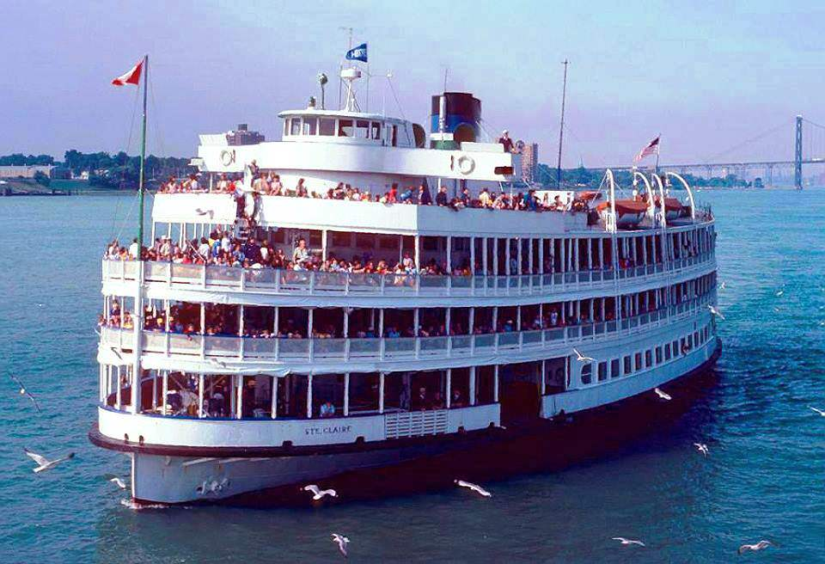
S.S. Columbia
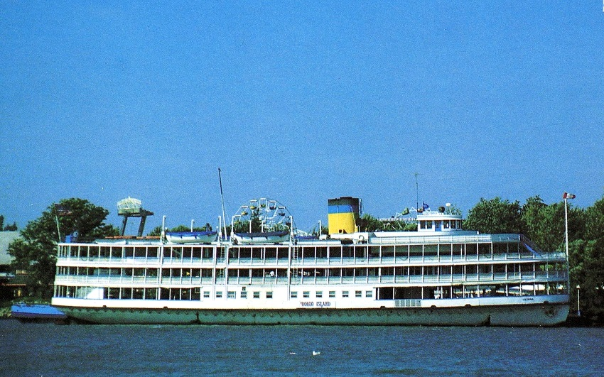

13
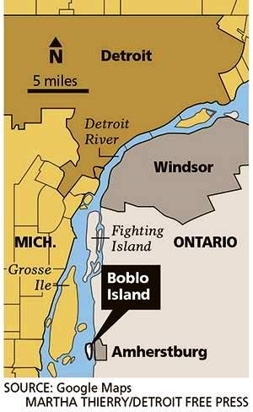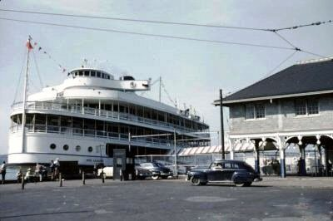
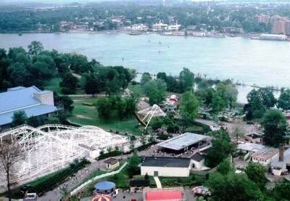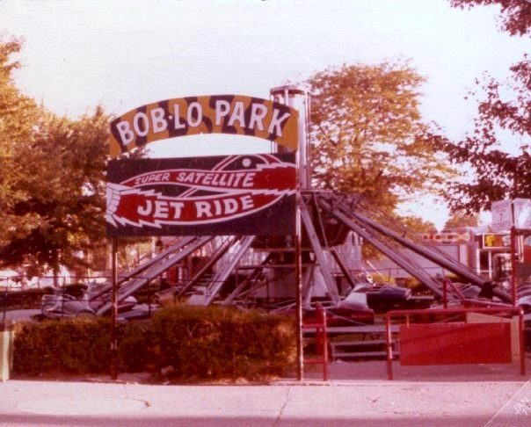

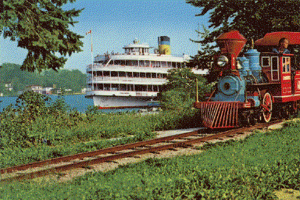

14
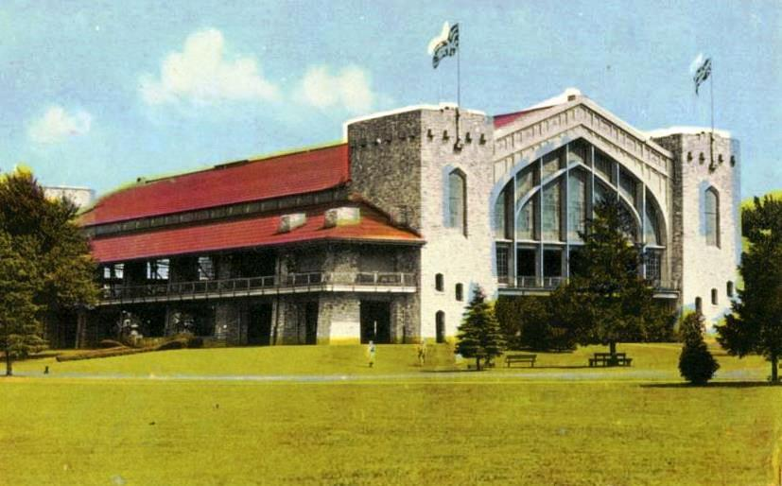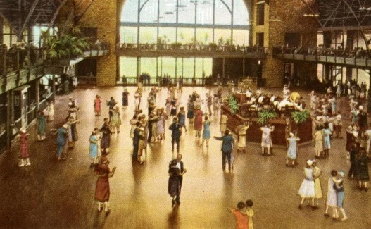
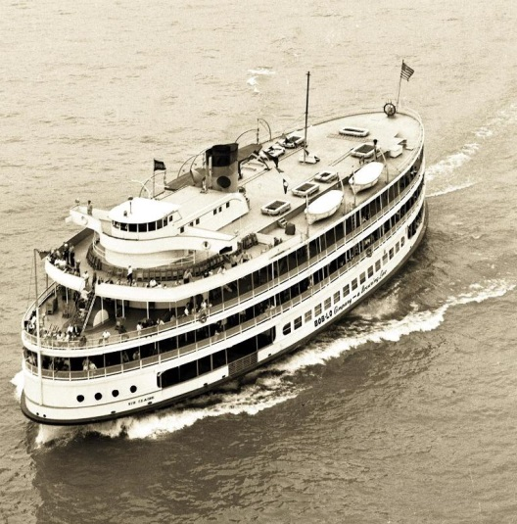

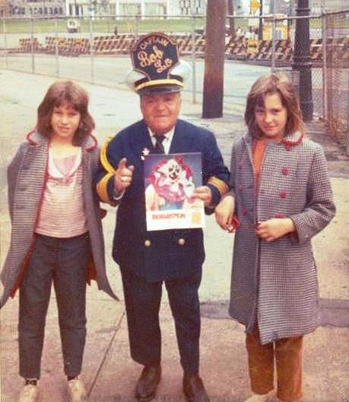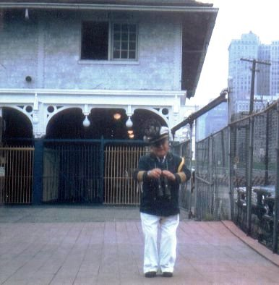
Captain Bob-Lo – Joe Short

15
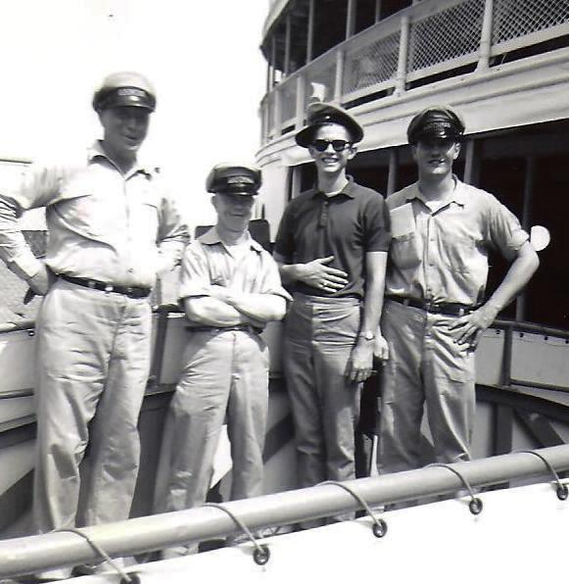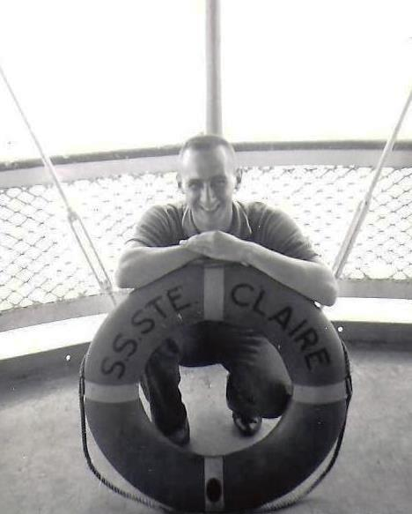
Deckhand: John Goforth

L-R: ??, Alton Boyd, ‘Doc’ & Bob Engleman

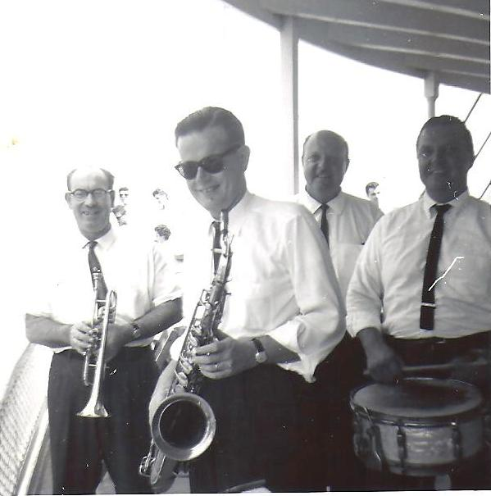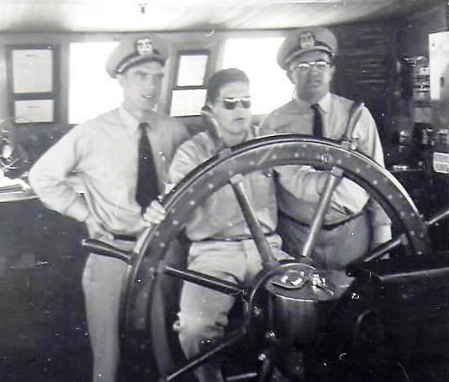
1st Mate Cal, Wheelsman, Art & ???

The Don Kepp Orchestra

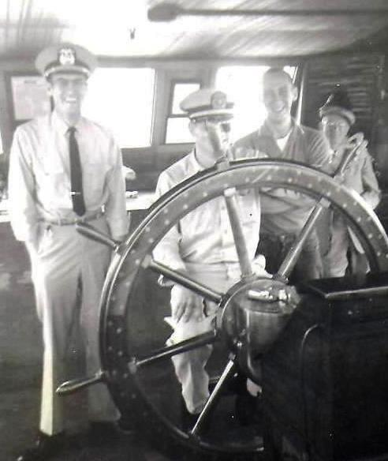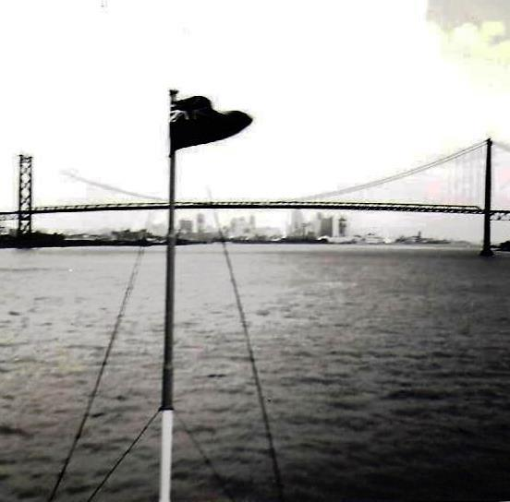
Last Trip of the Day…and Then:
“Moonlight Cruise”

2nd Mate Charlie, DH-Bob, John & Alton

16
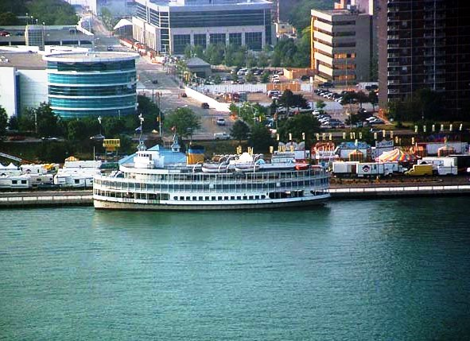
Foot
Of
Woodward
& the
Detroit
River
“Bob-Lo”
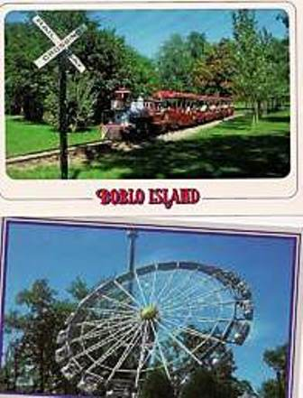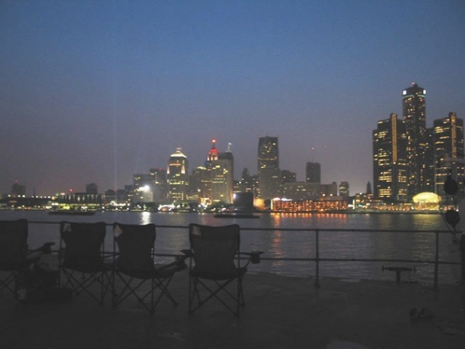
WINSOR CANADA
Tom O’Neal 1961-1962 Ste Claire Deckhand
Oh Bob-Lo…
“Your Spirit“
Will Remain
In our Hearts
Forever
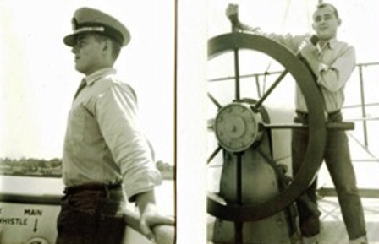

17

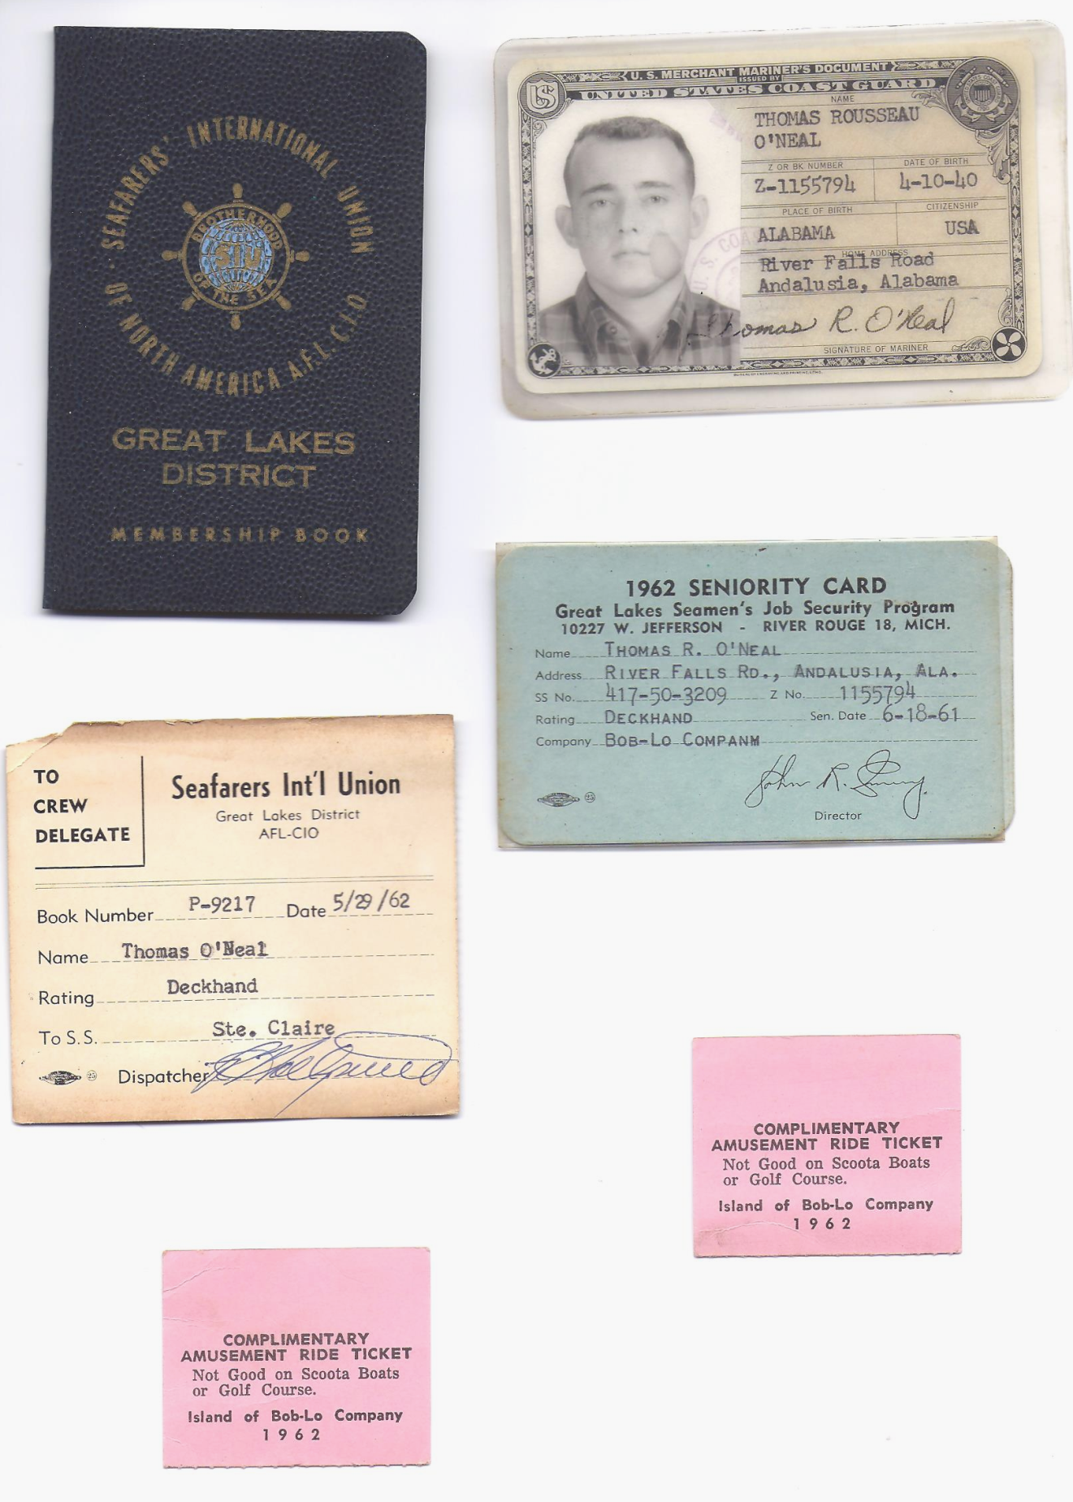

18

